APPENDIX A
PHOTOGRAPHS TAKEN DURING (LEAK) JIV AT 6” OGBOINBIRI/TEBIDABA PIPELINE AT KEME-EBIAMA COMMUNITY, SOUTHERN IJAW L.G.A, BAYELSA STATE ON 15TH JULY, 2024.

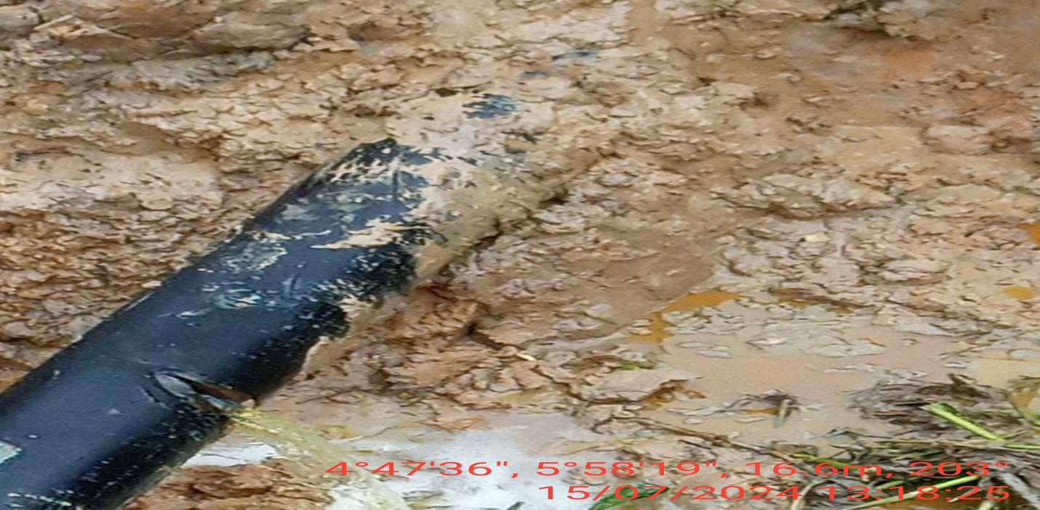
FIG. 1: ABOUT 130MM LONG CUT MADE BY VANDALS FROM 1-4 O’ CLOCK POSITION OF THE PIPELINE FOR POSSIBLE THEFT ACTIVITY.
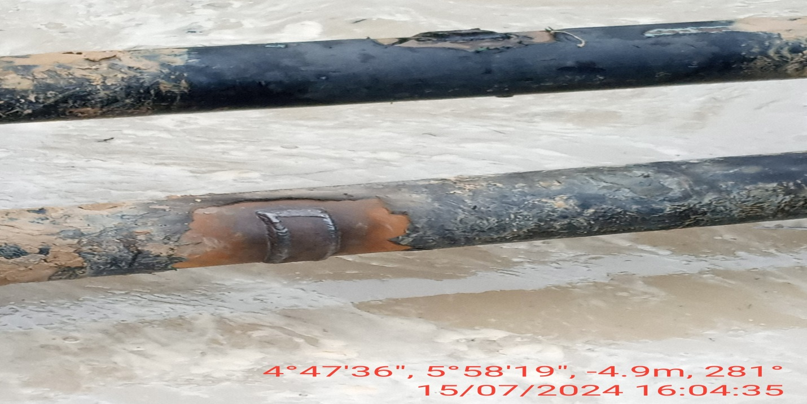
FIG. 2: THE INCIDENT POINT AFTER BEING PATCH WELDED.

